Facebook Mutual Friends:

The Map Reduce job running on Hadoop. The jar file extracted from IntelliJ Maven is kept in the source folder. The input is also given.

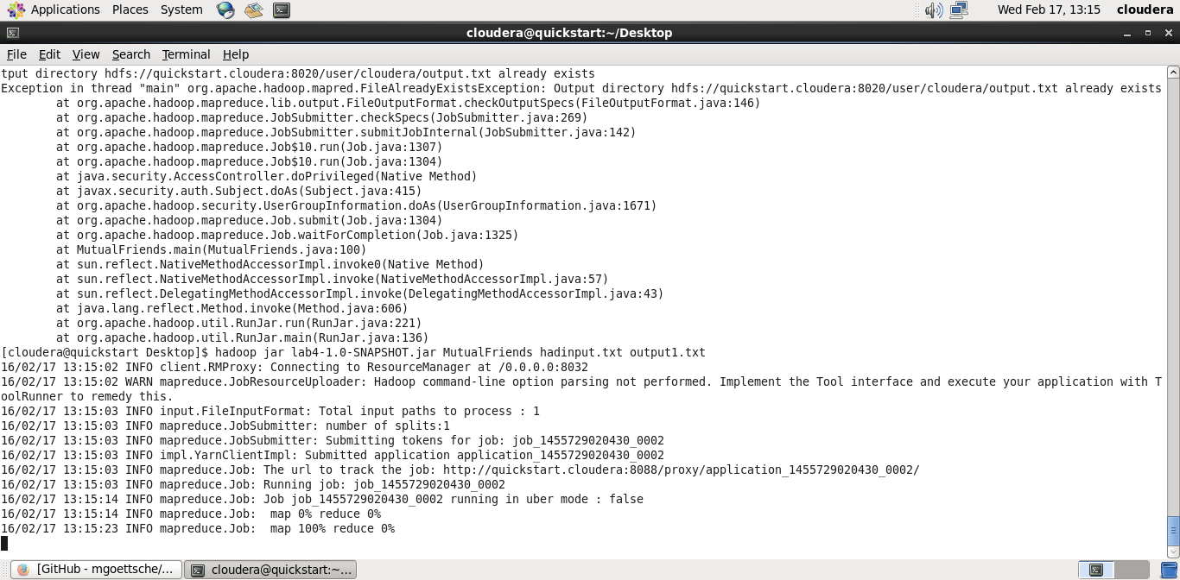

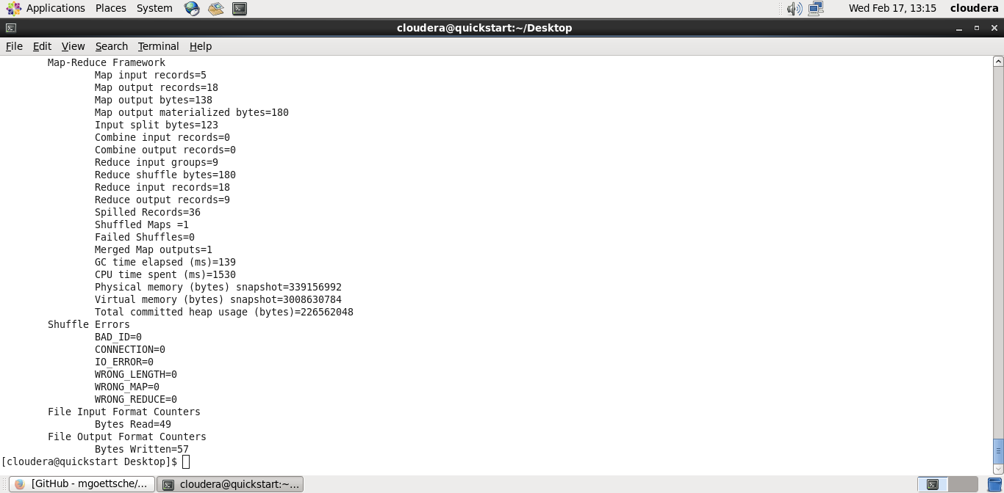

The output looks as below:

It is showing the mutual friends.

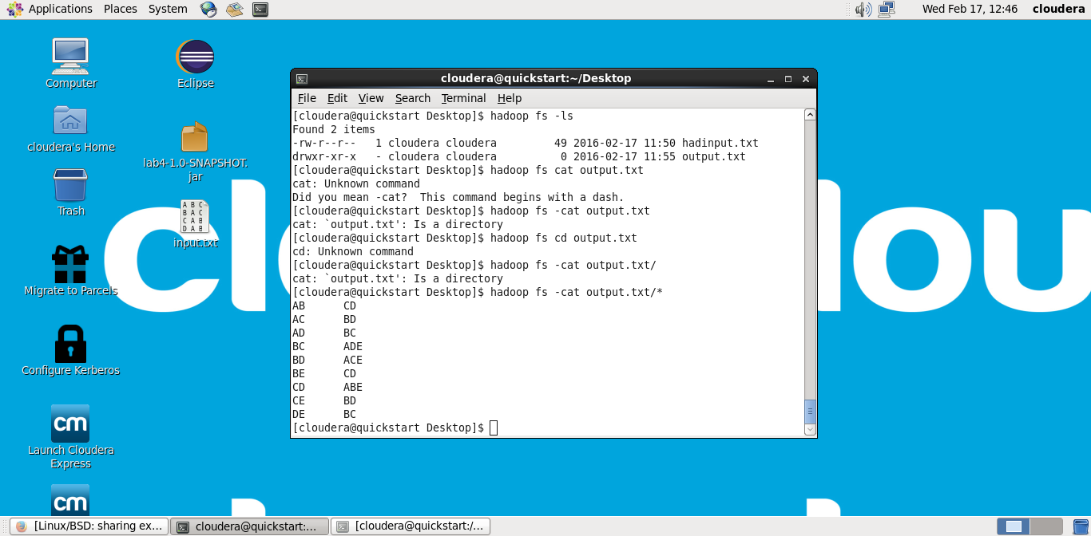

Android Studio Speech to text conversion:

The speech is converted into text and displayed.

